**Report For Runlinc**

**(A case study for Voice Story Telling App)**

By

Afolayan Oluwatimilehin Israel

080-452

**Introduction**

We want to make a simple phone app to tell a story. We want it to utilise runlinc’s ability to integrate STEM, AI and IoT into projects.

Storytelling is important as it enables us to pass information on to other people. runlinc can be used for STEM, AI and IoT. We want our storytelling app to use all three of these applications.

We will use the runlinc web app form to generate our app. This will create an app which makes use of the accelerometer in the phone (STEM), send an email (IoT), and uses the browser’s text to speech synthesis (AI).

**Visual Content**

Creating the Web App on runlinc storytelling App Form

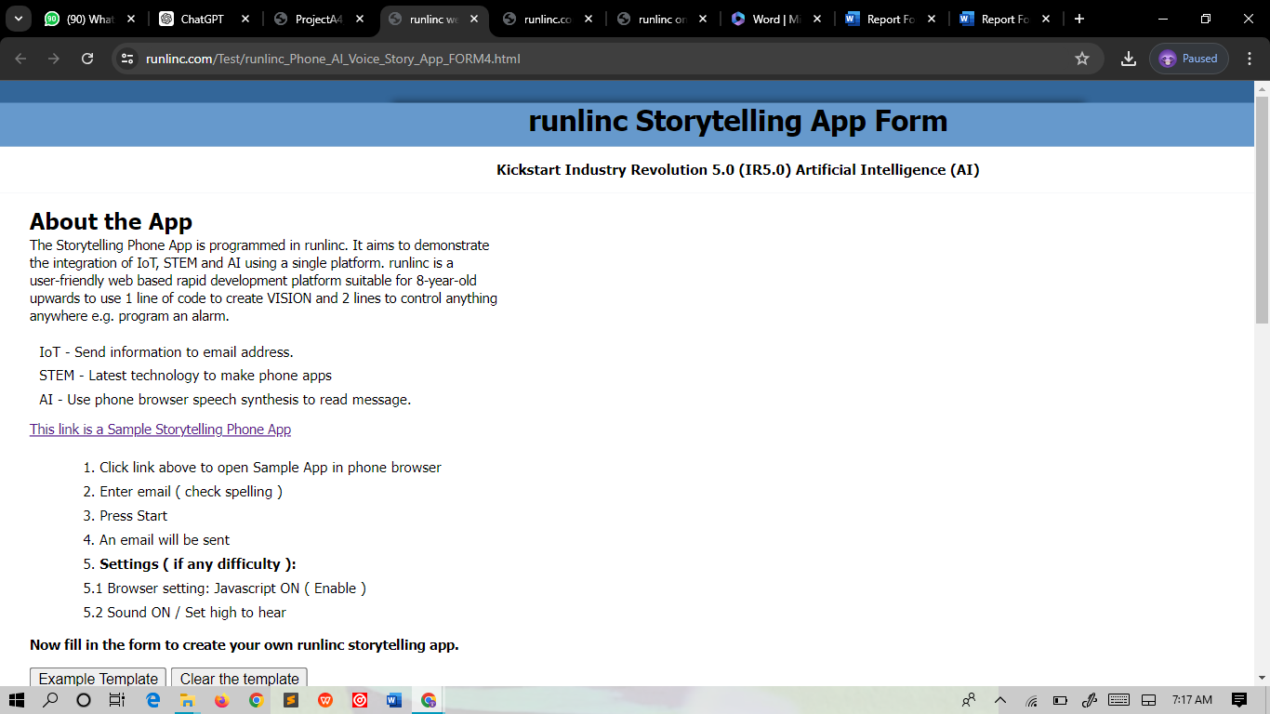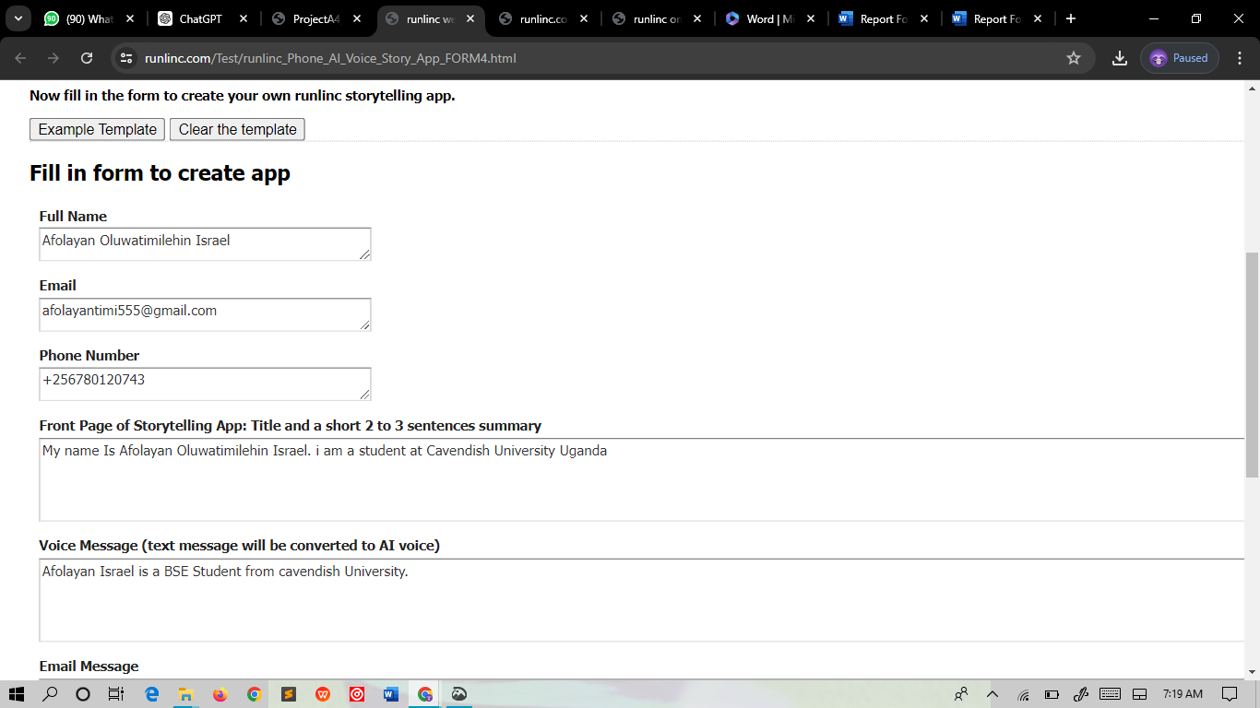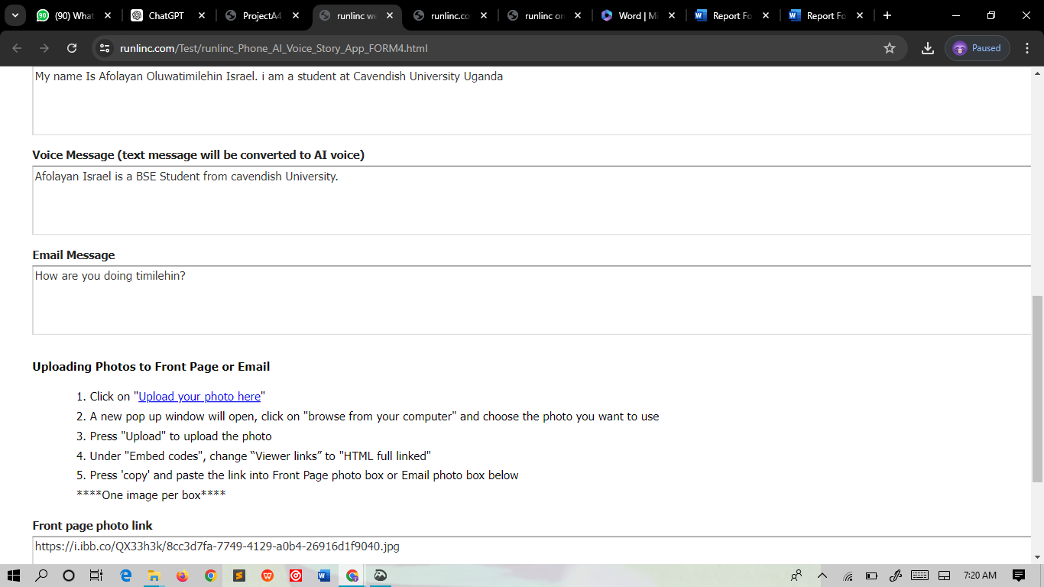

Below is what the speech synthetic AI says:

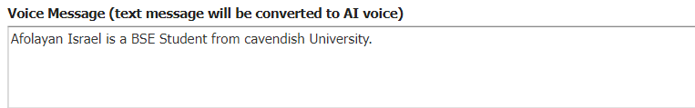

Below is the output of this form created:

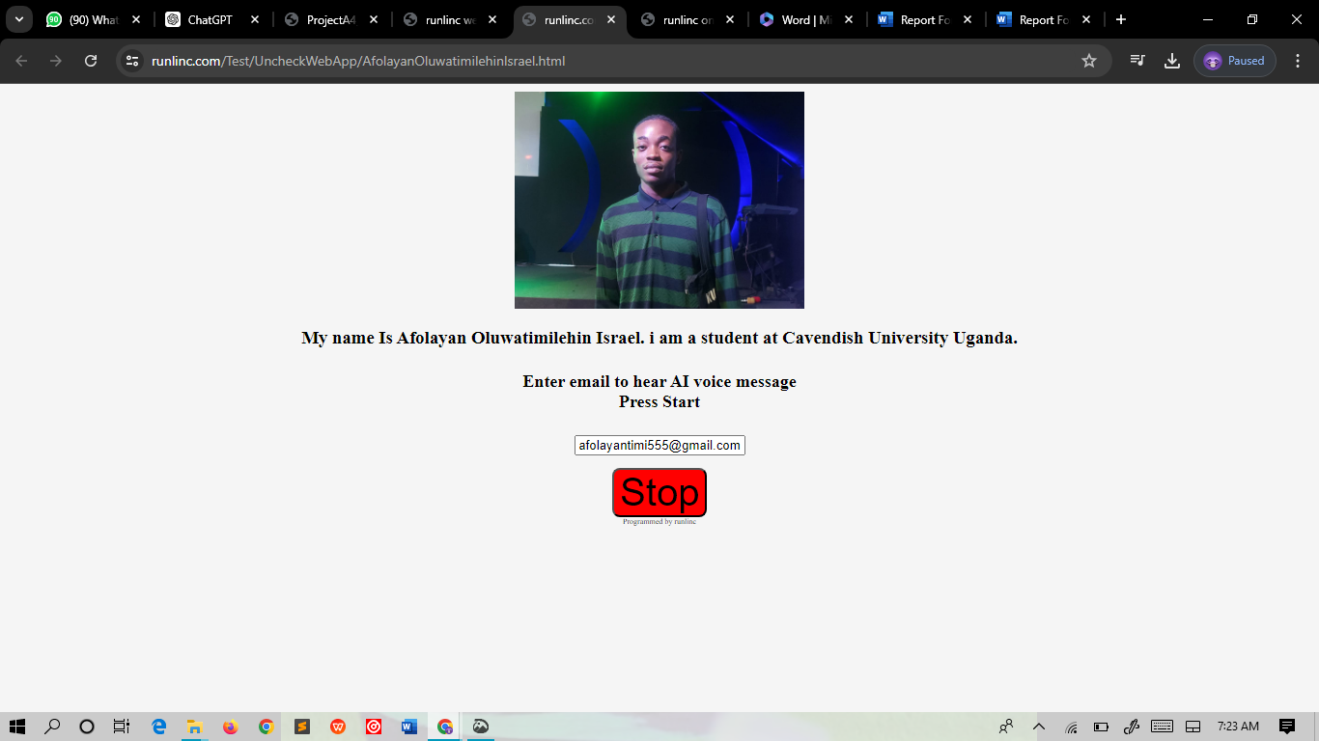

**Link to the web page:**

https://runlinc.com/Test/UncheckWebApp/AfolayanOluwatimilehinIsrael.html